1.

(a)

frozenset({frozenset({'A', 'C'}),

frozenset({'B', 'D', 'Z'}),

frozenset({'A', 'D'}),

frozenset({'B'}),

frozenset({'B', 'Z'}),

frozenset({'A', 'B', 'Z'}),

frozenset({'C', 'Z'}),

frozenset({'A', 'C', 'D'}),

frozenset({'B', 'C'}),

frozenset({'B', 'D'}),

frozenset({'D', 'Z'}),

frozenset({'B', 'C', 'Z'}),

frozenset({'B', 'C', 'D', 'Z'}),

frozenset({'A'}),

frozenset({'A', 'D', 'Z'}),

frozenset({'A', 'B'}),

frozenset({'A', 'B', 'C'}),

frozenset({'B', 'C', 'D'}),

frozenset({'A', 'B', 'D'}),

frozenset({'C', 'D', 'Z'}),

frozenset({'A', 'Z'}),

frozenset({'A', 'C', 'Z'}),

frozenset({'A', 'C', 'D', 'Z'}),

frozenset({'A', 'B', 'C', 'Z'}),

frozenset({'A', 'B', 'D', 'Z'}),

frozenset({'A', 'B', 'C', 'D'}),

frozenset({'A', 'B', 'C', 'D', 'Z'})})

(b)

frozenset({'A'}),

frozenset({'B'}),

frozenset({'C', 'Z'}),

frozenset({'D', 'Z'}),

(c)

**D on Y**

['A', 'Z']

['B', 'Z']

['C']

['T', 'Z']

['W', 'Z']

W on Y

['A', 'Z']

['B', 'Z']

['C', 'Z']

['D', 'Z']

['T']

**{W, D} on Y**

[‘Z’]

(d)

[‘w’]

2.

3.

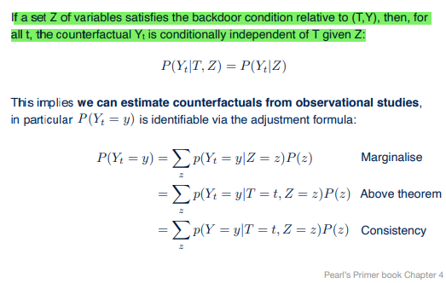

4.

P(T=t’) = 1-P(T=t)

E[Y_t|T=t’] = p(Y = y|do(T = t)) ->backdoor